Computer system

Yehor Burlachenko

My dream computer

**Introduction.**

To be honest, all my life I have a dream to have the most powerful computer with 2 monitors.

So, now I will show you example of my dream set-up.

**HW features.**

We are going to start with peripheral devices.

How I told you, my dream is to have 2 monitors to be able to do some things at one time. Por example play and watch some series. I have chosen those monitors.

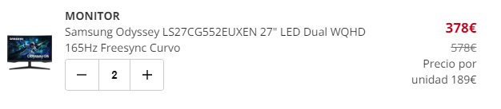

Then I got a RGB gaming keyboard:

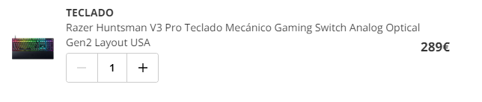

Mouse and headphones I decided to choose from logitech:

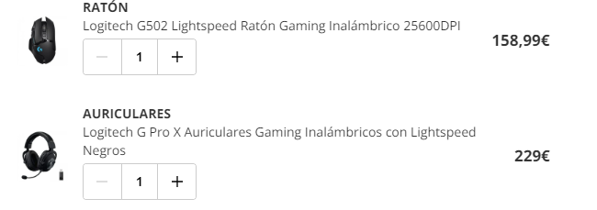

Now we are starting with a case, the most interesting part.

Like a heart I took Intel Core I9:



The motherboards:



RAM memory is DDR5, two parts of 32GB, so 64GB in total: 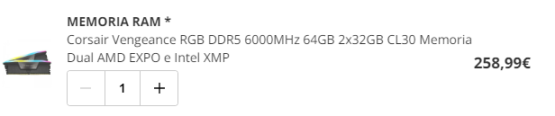

Almost the best one graphic card 4080:

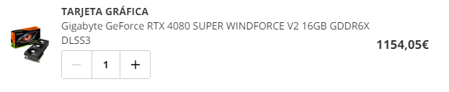

With liquid cooling, because I think is the best one:



And power unit is 850W:



I got one disk of 2 TB HDD and one 1TB SSD because of security questions:

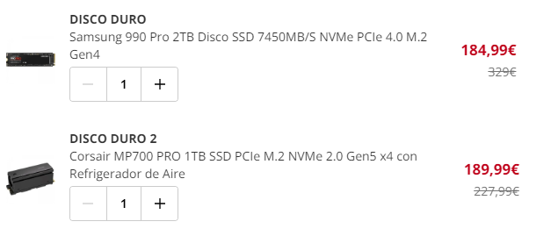

Sound card:



And o beautiful case:

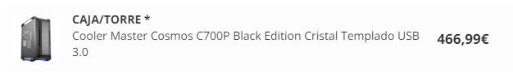

**Budget.**

In total my dream set-up will cost me 5295.05 €.

**Conclusion.**

With this work I searched some components of computers, now I know more or less how to find out my dream computer and price of it.